

**URBANA DIGITAL**

**ARCHITECTURE, DESIGN AND 3D VISUALIZATION OFFICE**

**CURRICULUM & PORTFOLIO**

Silvestre Vivo Millán, Architect.

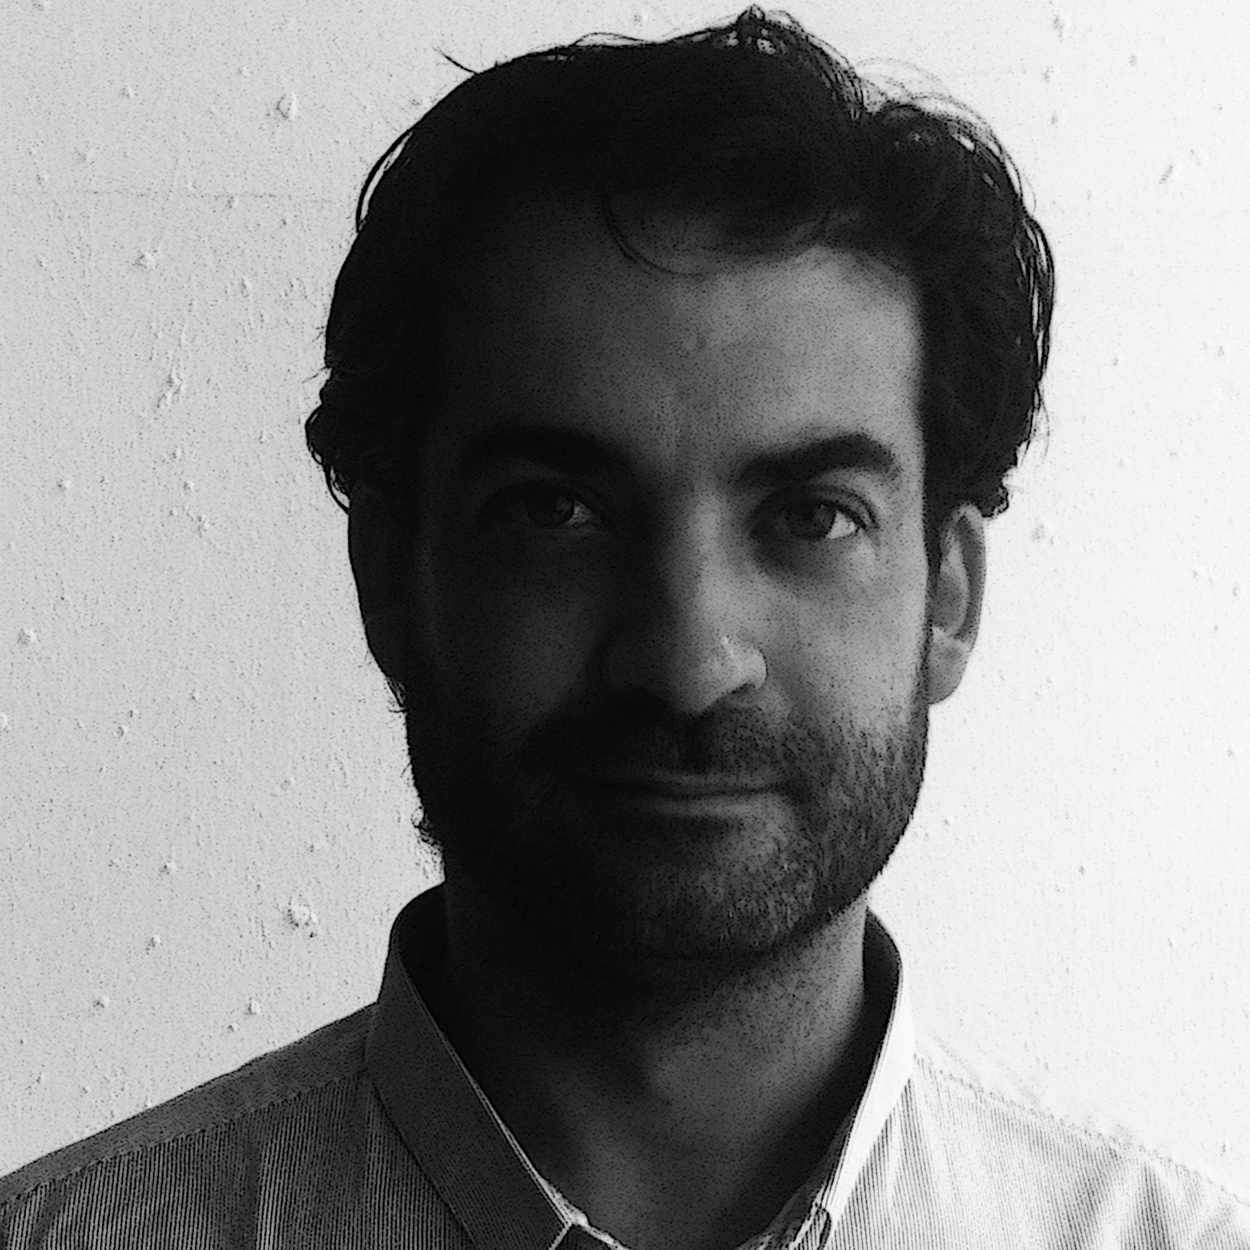

**Curriculum Vitae**

**Personal Information**

Name | Surname Silvestre Vivo Millán

Address Wilhelminastraat 108,1 -1054WN

Amsterdam (Nederland)

Cell phone +31 064 7651302

Email info@urbanadigital.eu

Nationality Spanish

Date of birth 25/11/1976

Gender Male

**Education and training**

Date 1995-2003

Title of qualification awarded **Bachelor of Architecture with the classification**: **8/10**

Principal subjects/occupational Design, urban design, technological design, bioclimatic design, renovation design, history and theory of architecture, science and technical of construction.

Organization University of Seville – Spain

Final project Urban Planning around the environment of the Barbate River. Renovation and recycling of uses in the consolidate city.

Coordinator Professor D. Pedro Górgola, University of Seville.

Date 2007/09

Title of qualification awarded **Master in City and Sustainable Architecture with the classification: 10/10**

Principal subjects/occupational theory of sustainability, rehabilitation, alternative energy, new urban processes on consolidated environments, theories energy and distributed generation, hydrogen and fuel cells, recycling, reuse, refurbishment, generic city, specific city, augmented reality, social networking applied to urban planning

Organization University of Seville – Spain

Final project Energy; city, hydrogen, electricity. Researching project on the use of hydrogen as an energy vector for the development of distributed generation of energy in the city.

Coordinator Professor D.Carlos Tapia Martín, University of Seville.

Date 2011-2013

PhD thesis **“The human scale of energy” Study and research on imaginary city in an environment of distributed generation of energy.**

Coordinator Professor D.Carlos Tapia Martín, University of Seville.

**Learning experience**

Date 2009

Workshop **About sustainability en Latin America**

Organization University of Valparaíso-Chile

Coordinator Profesora Dña. Carmen Guerra de Hoyos University of Seville.

Date 2009

**Visiting professor in Master in City and Sustainable Architecture**

Organization University of Seville - Spain

Date 2009

Researching project **“H2oPe: The new hydrogen technologies and the fuel cells in the future urban planning”, with the classification: 9/10**

Organization Foundation San Valero, Zaragoza (Spain)

Date 2010

National Congress **Sustainability and Environment, paper about energy, distributed generation and hydrogen technology**

Organization Asociación de Ambientólogos de España

Place Rivas Vacía-Madrid (Madrid)

Date 2010

Regional Congress **Sustainability and Environment, paper about energy, distributed generation and hydrogen technology**

Organization Asociación de Ambientólogos de Andalucía

Place Seville – Andalusia (Spain)

Date 2010

**Visiting professor in Master in City and Sustainable Architecture**

Organization University of Seville - Spain

**Publications**

2009 **Hybridization and transculturation in contemporary inhabit modes**. In collaboration with the researching group “Outarquías”. [**http://outarquias.wordpress.com/**](http://outarquias.wordpress.com/)

2010 Paper for I State Sustainability Congress – Ambientalia 2010. **Energy; city, hydrogen, electricity.** [**http://estatal.ambientalia.org/**](http://estatal.ambientalia.org/)

2010 Paper for V Regional Sustainability Congress – Ambientalia 2010. **Towards a new model of city.** [**http://andalucia.ambientalia.org/**](http://andalucia.ambientalia.org/)

2011 “**The human scale of energy**”. Research article for the spanish on-line magazine Hipo-Tesis [**http://www.hipo-tesis.eu/numero_hipo_g.html**](http://www.hipo-tesis.eu/numero_hipo_g.html)

2011 “**Search found**”. Research article for the spanish on-line magazine Hipo-Tesis [**http://www.hipo-tesis.eu/numero_hipo_i.html**](http://www.hipo-tesis.eu/numero_hipo_i.html)

2011 **Five years of MCAS. Summary of the most important thesis in the last years.** University of Seville. **http://mastercas.net/**

**Work experience**

Date 2001-2003

Name of employer **MRPR Arquitectos**

Type of business or sector Architecture Studio

Occupation or position held Collaborator

Main activities urban planning, building design, competitions

Date 2003

Name of employer **AGU Arquitectura y Urbanismo**

Type of business or sector Architecture Studio

Occupation or position held Collaborator and Manager

Main activities urban planning, building design, housing projects.

Date 2003-2014

Name of employer **Urbana Digital**

Type of business or sector Architecture Studio

Occupation or position held Director and designer, owner of the company

Main activities all activities related to the direction and management of an architectural firm; design, competitions, projects, coordination of construction, drawing, 3D models, etc…

Date 2011

Name of employer **Studio Seven Architecten**

Type of business or sector Architecture Studio

Occupation or position held Collaborator with a Dutch architectural firm doing projects in The Hague.

Main activities projects, drawing, 3D models, etc…

**Prizes**

2004 First Prize – 10 bioclimatic housing in Castilleja de la Cuesta- Seville (Spain)

2007 First Prize - Childhood dining room in Tomares (Seville)

2007 First Prize - School in Tomares (Seville)

2009 Second Prize - 41 housing in Benamejí (Cordoba)

2009 Second Prize – 22 housing in Aracena (Huelva)

2011 Finalist – Housing in Avila.

2014 First Price with Studio Seven Architecten – Renovation Building office

**Interests** Musician, guitar teacher, and photographer at free time. All these activities developed in The Hague.

**Languages** Spanish, English and Dutch**.**

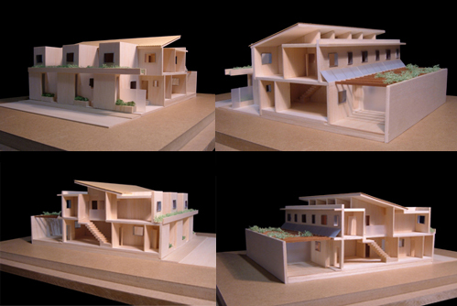**1 10 bioclimatic housing** Competition: First Price 2004Place: Seville (Spain)

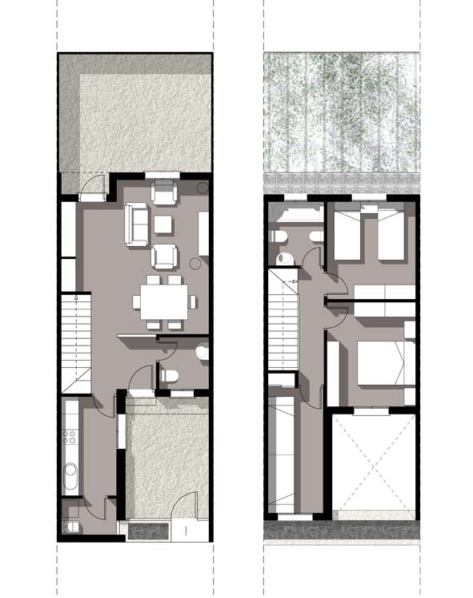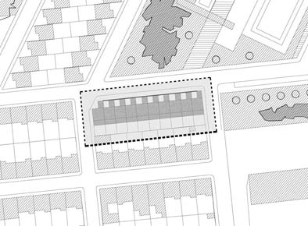

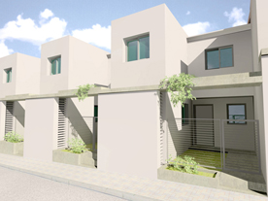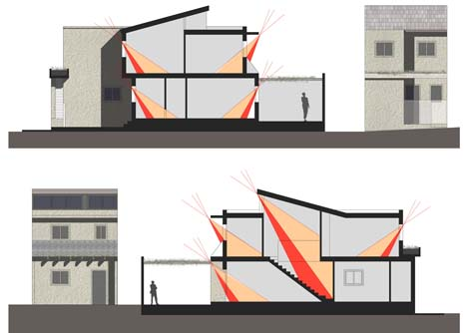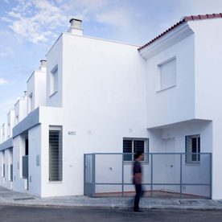

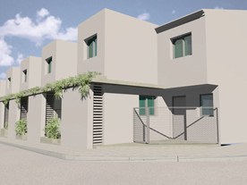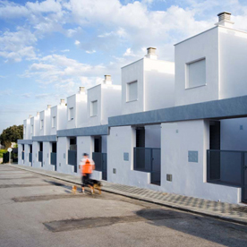

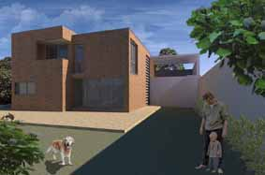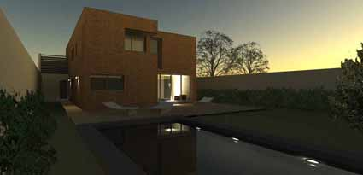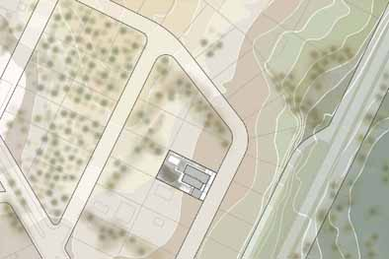**2 singular housing** Private client, 2005 Place: Seville (Spain)

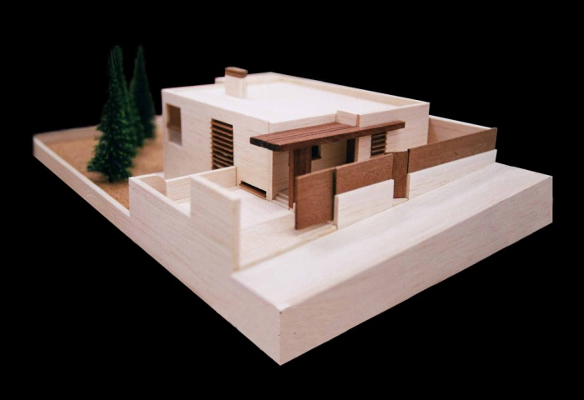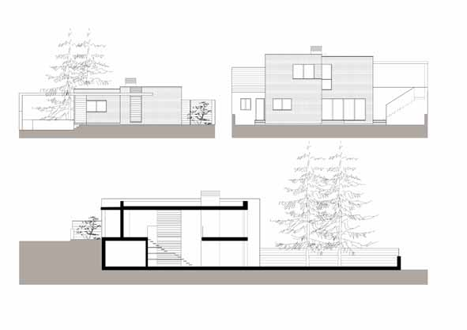

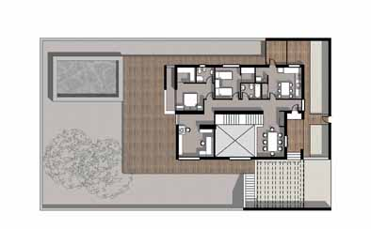

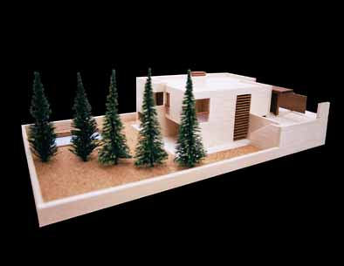

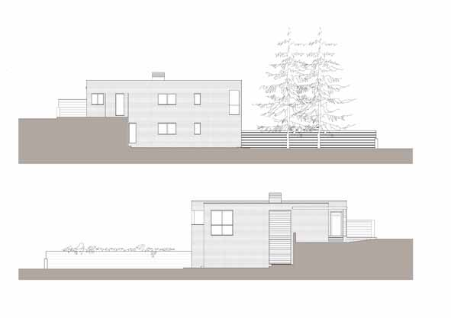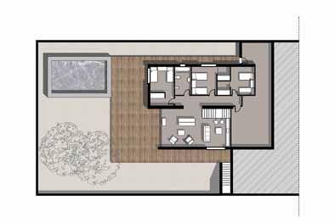

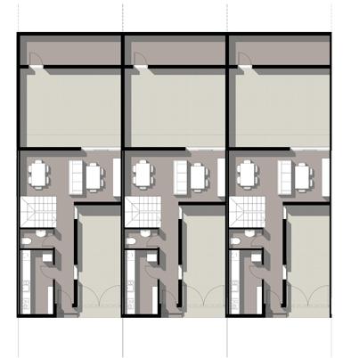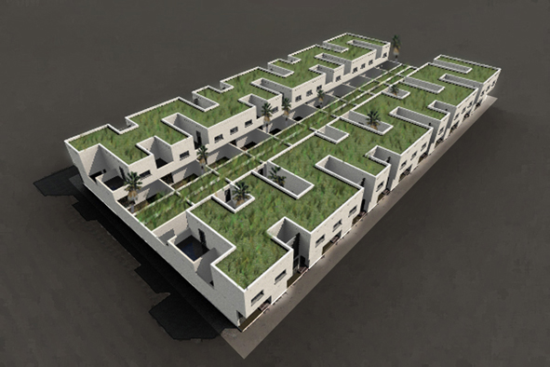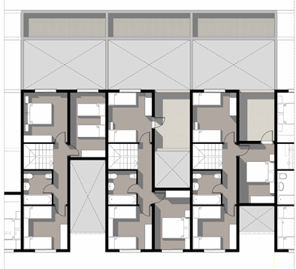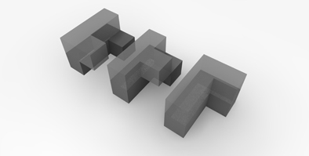**3 41 housing** Competition: Second Price 2009 Place: Cordoba (Spain)

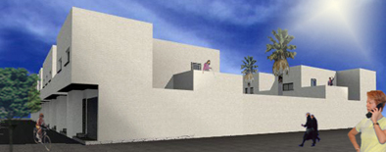

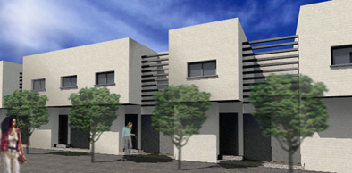

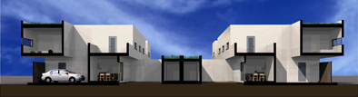

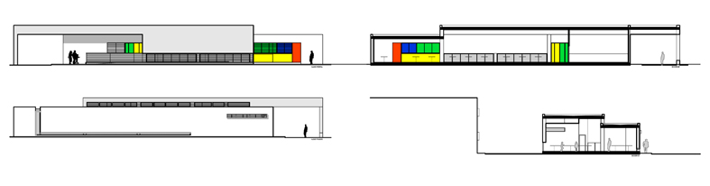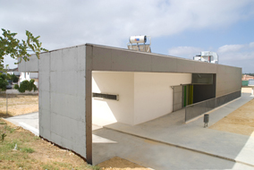**4 childhood dining room** Competition: First Price 2007 Place: Sevilla (Spain)

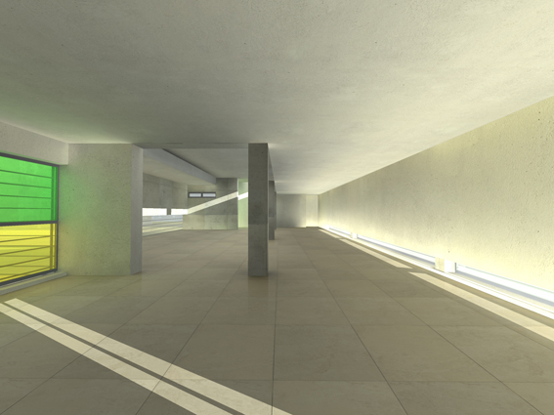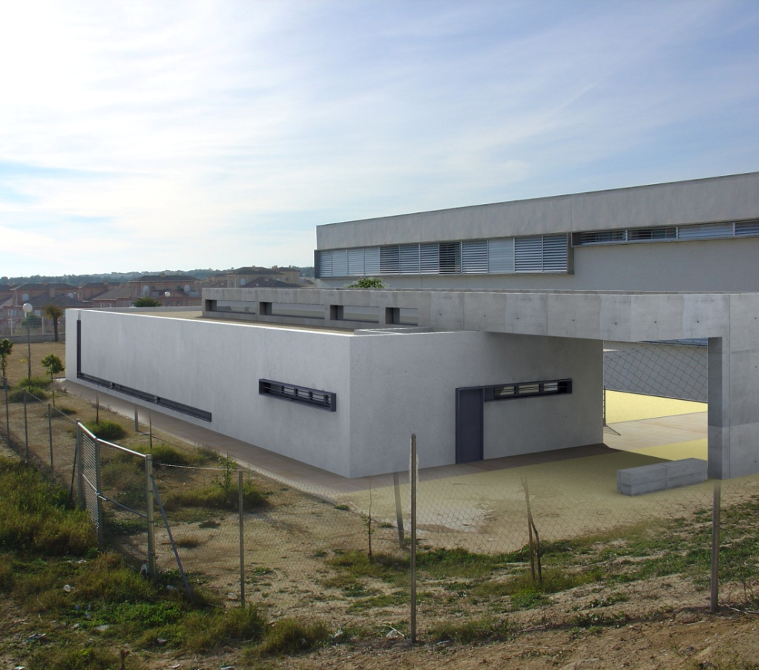

**5 library, gym and new dining room in school** Competition: First Price 2007 Place: Sevilla (Spain)

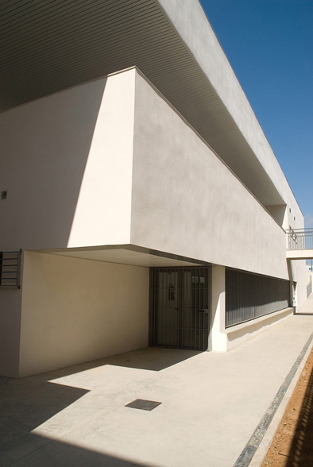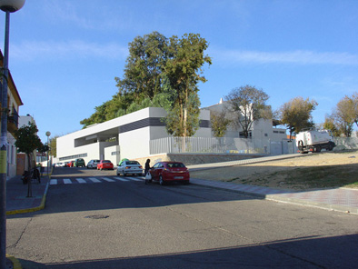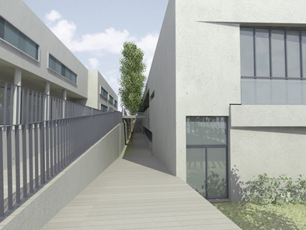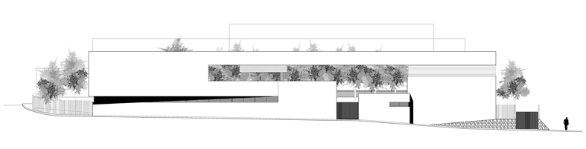

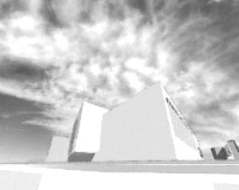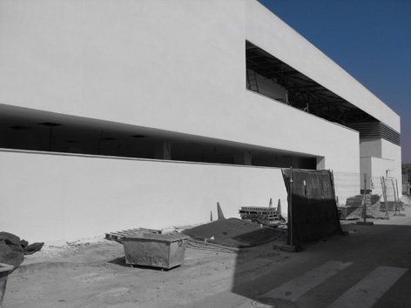

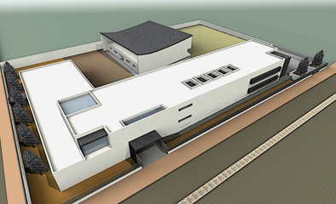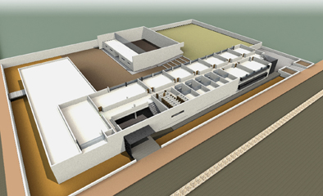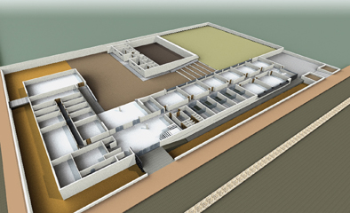**6 new primary school** Competition 2010 Place: Sevilla (Spain)

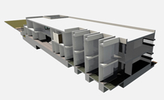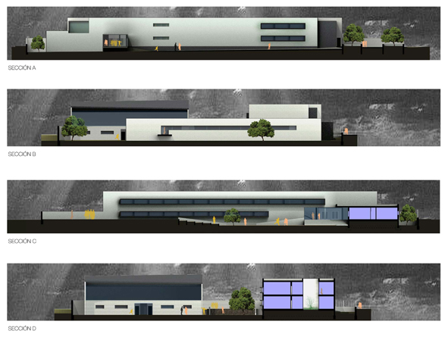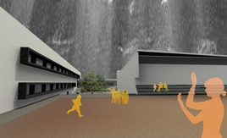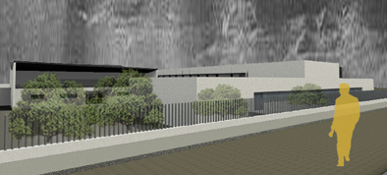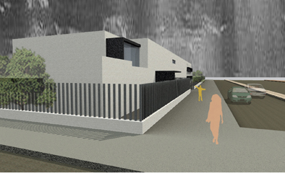

**7 gas station** Private Client 2010 Place: Seville (Spain)

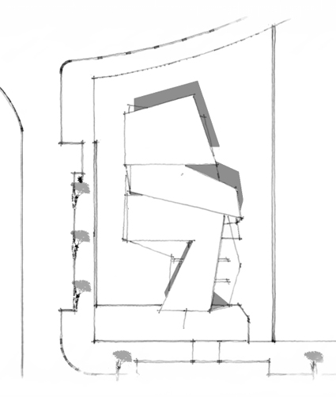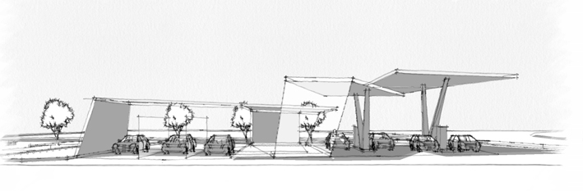

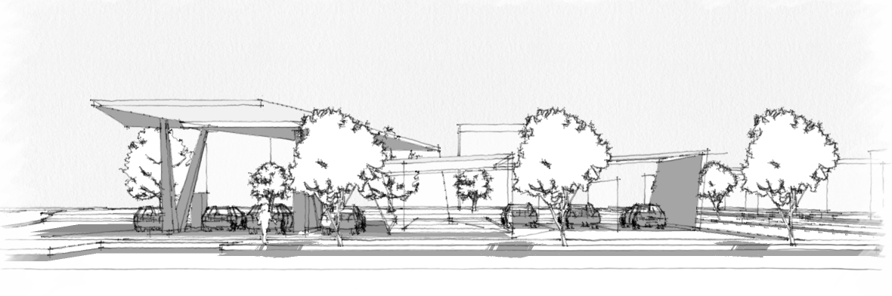

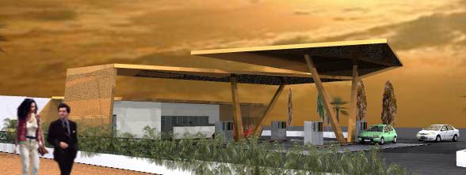

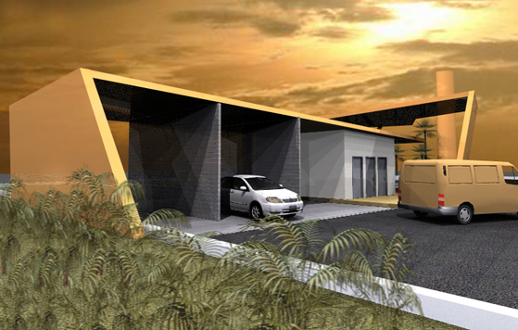

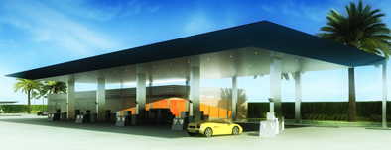**8 gas station** Private Client 2011 Place: Abu Dhabi (United Arab Emirates)

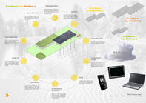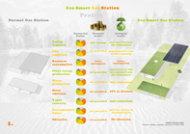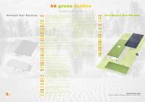

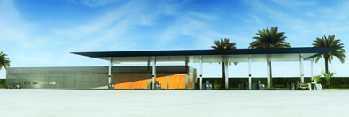

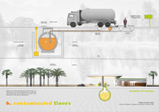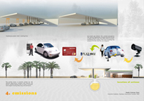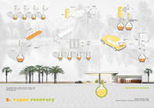

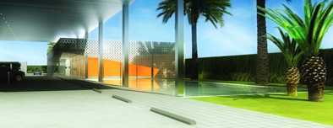

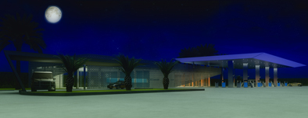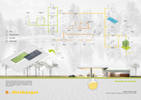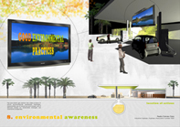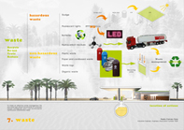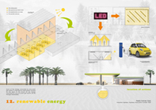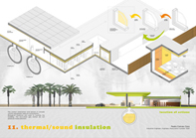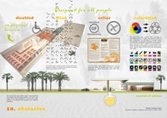

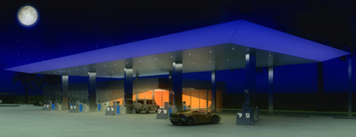

**9 singular housing** Competition: Finalist 2011 Place: Ávila (Spain)

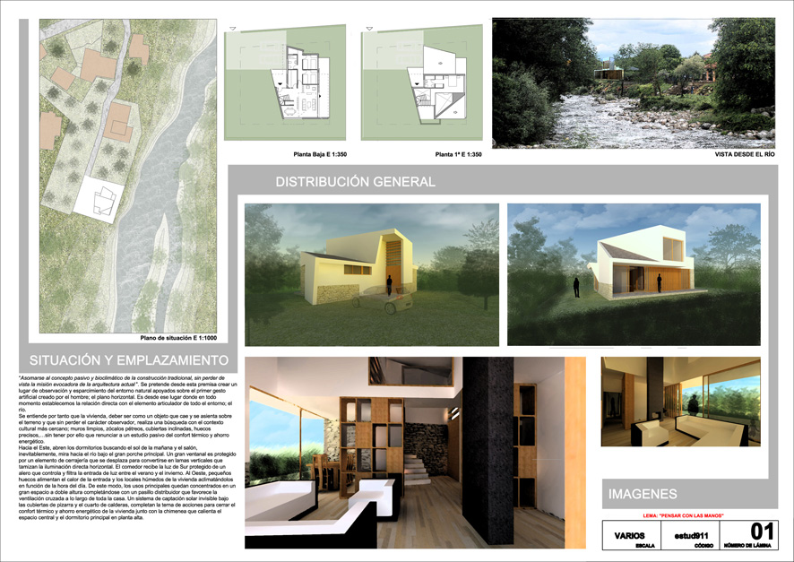

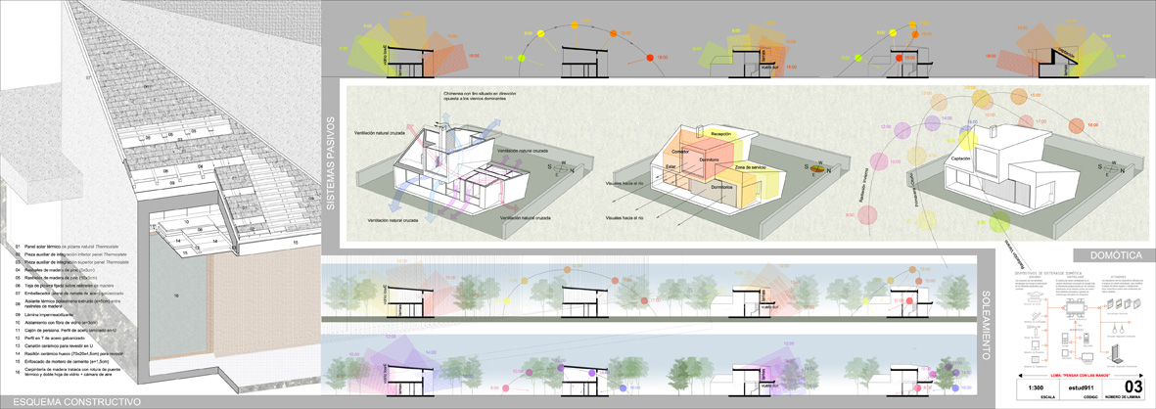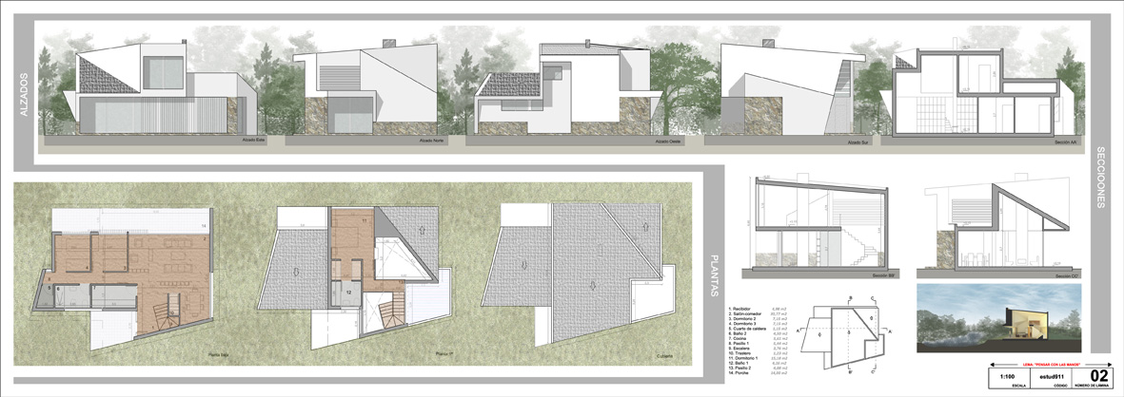

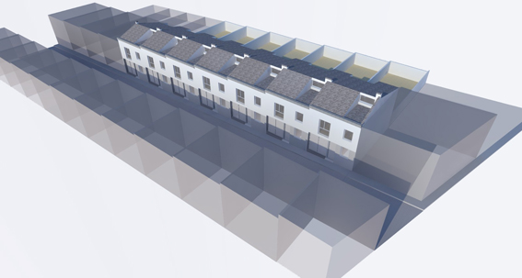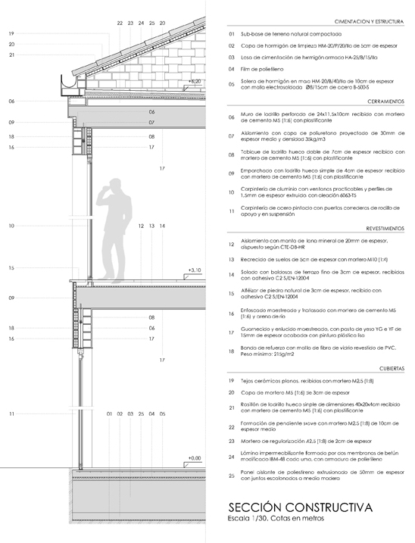**10 16 housing** Competition 2011 Place: Cordoba (Spain)

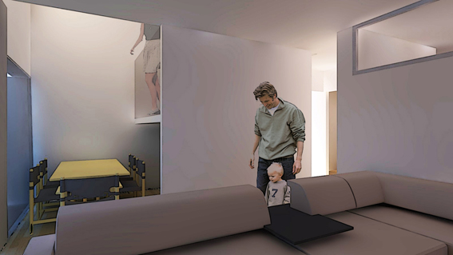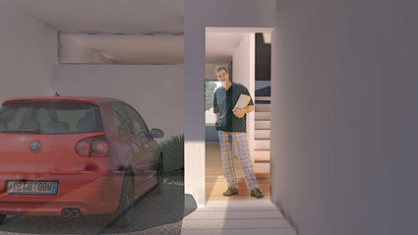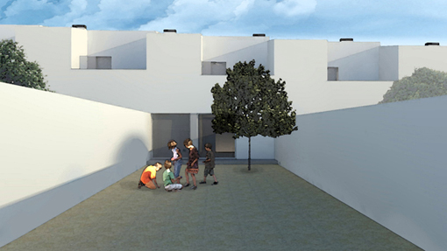

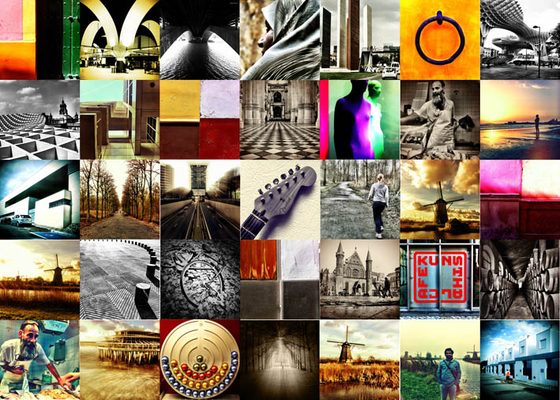**11 photograph** Exhibition 2010/2011 Place: Sevilla (Spain)

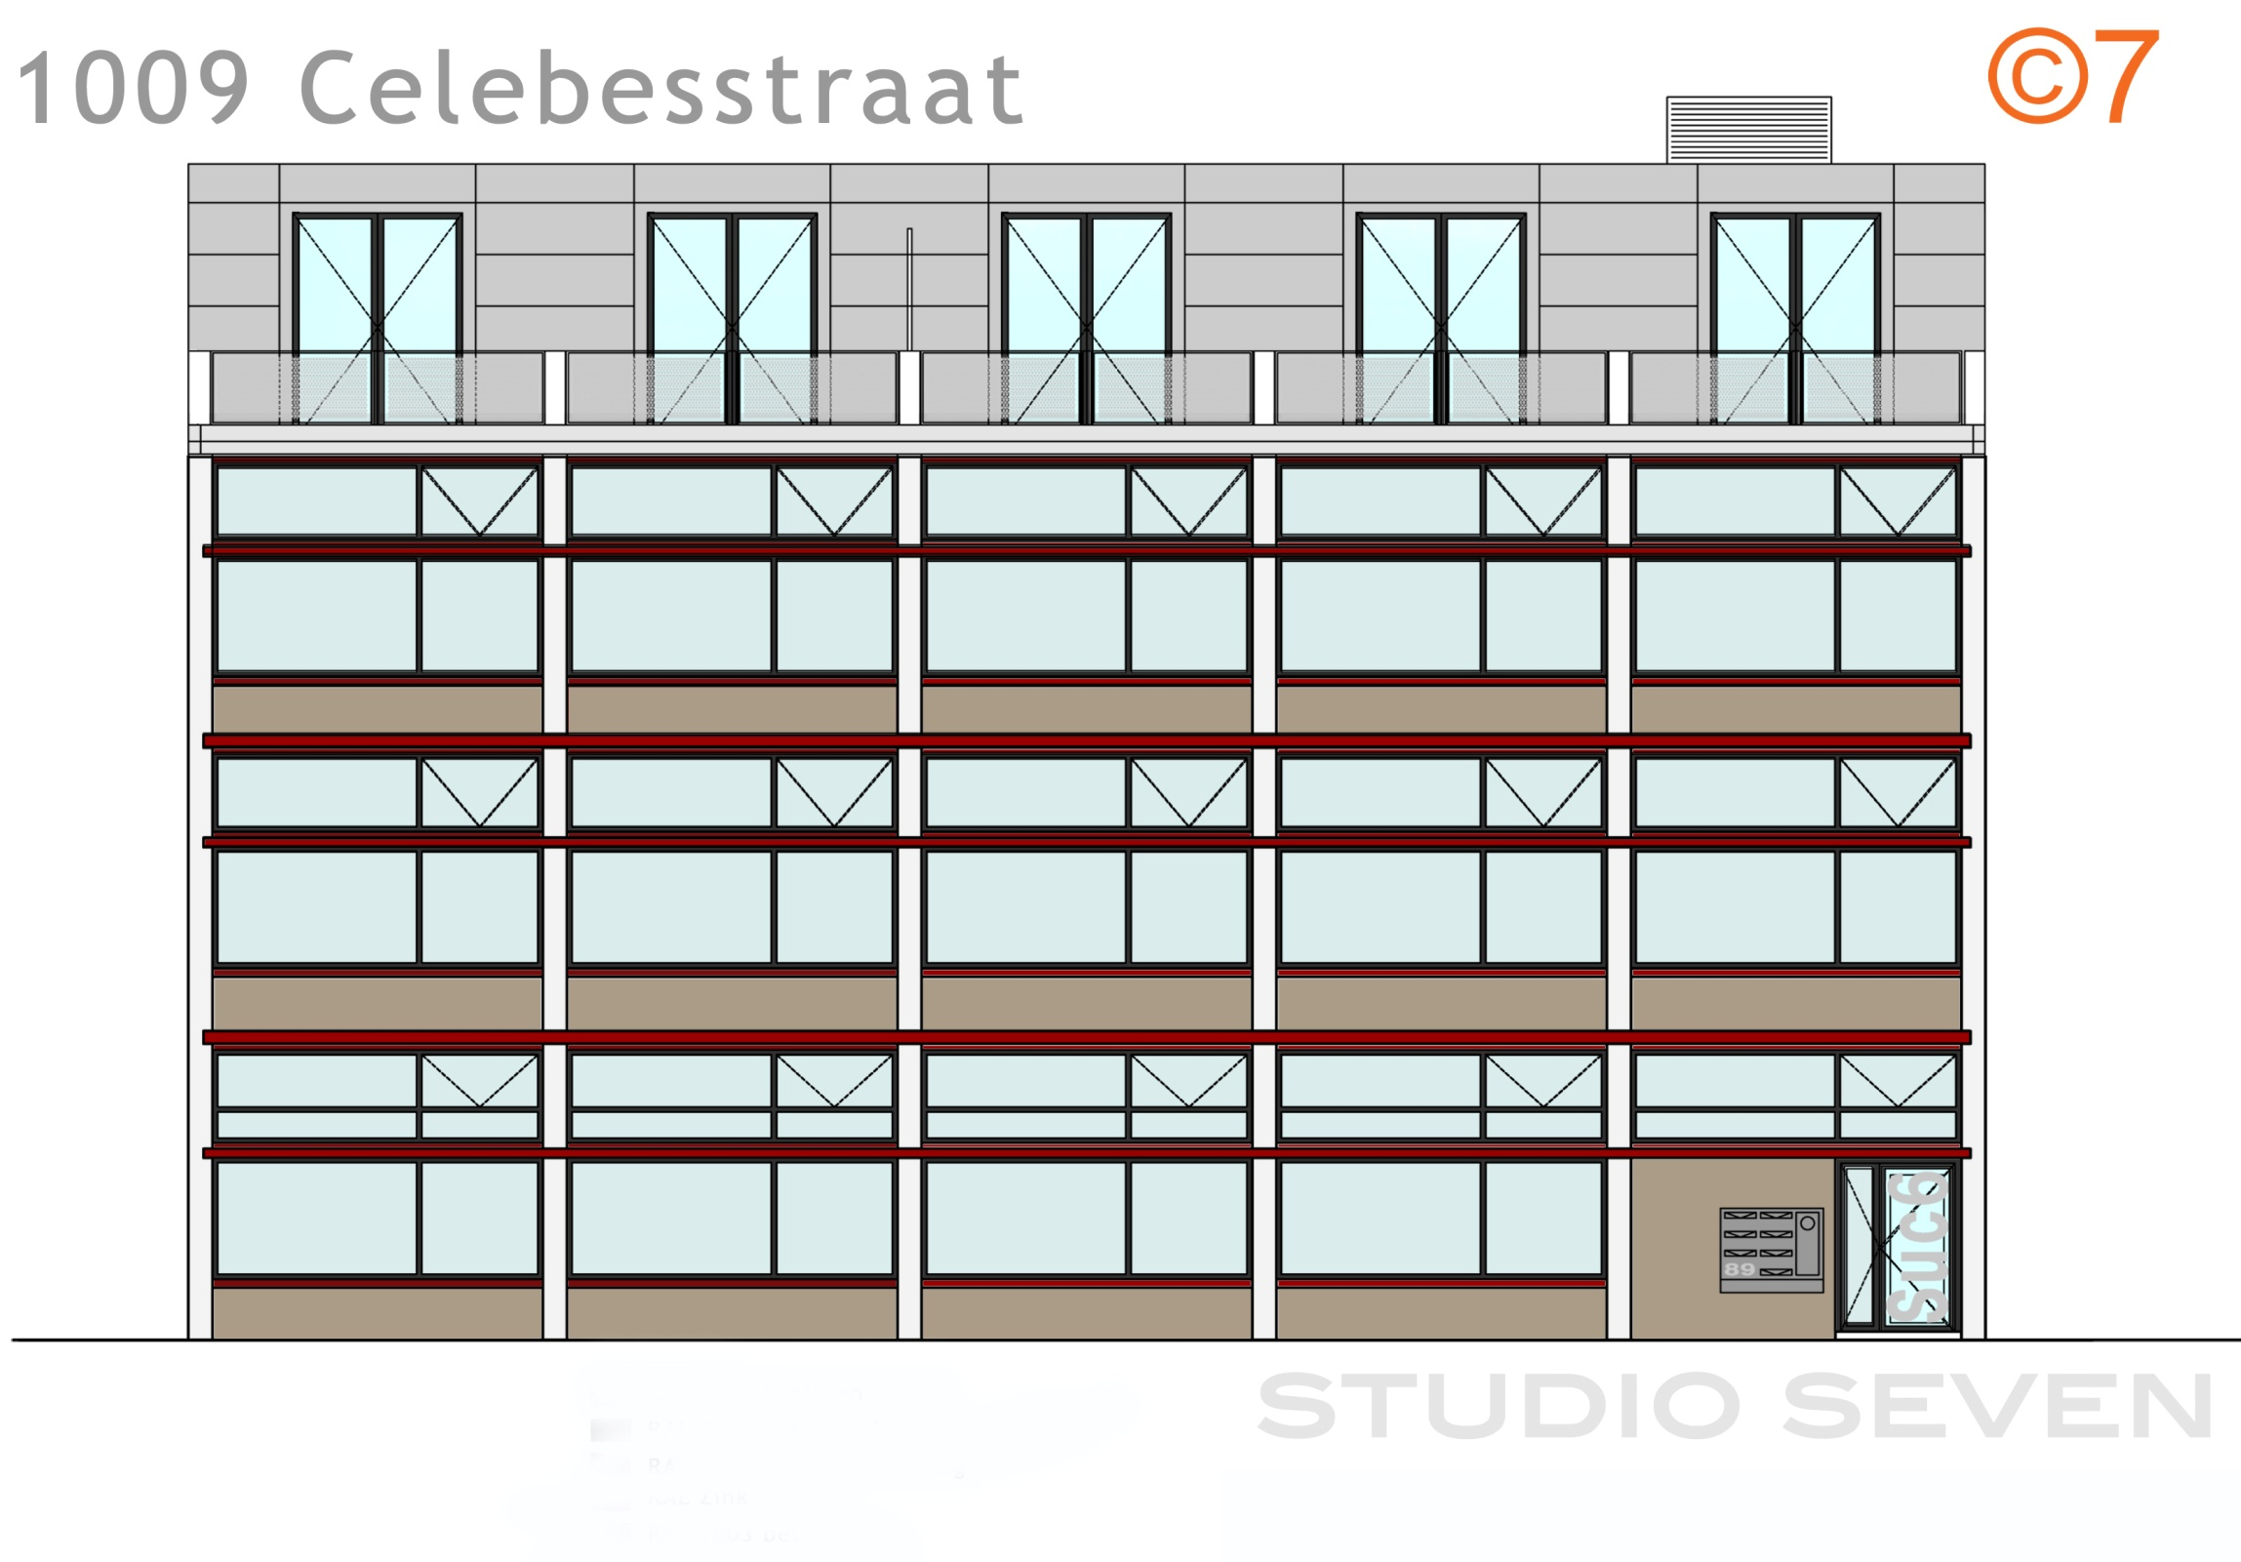**12 housing building** In collaboration with Studio Seven Architecten 2012 Place: The Hague (The Netherlands)

**13 New Public Building In York** Competition in collaboration with Hugh Geoghegan 2013 Place: York (United Kingdom)

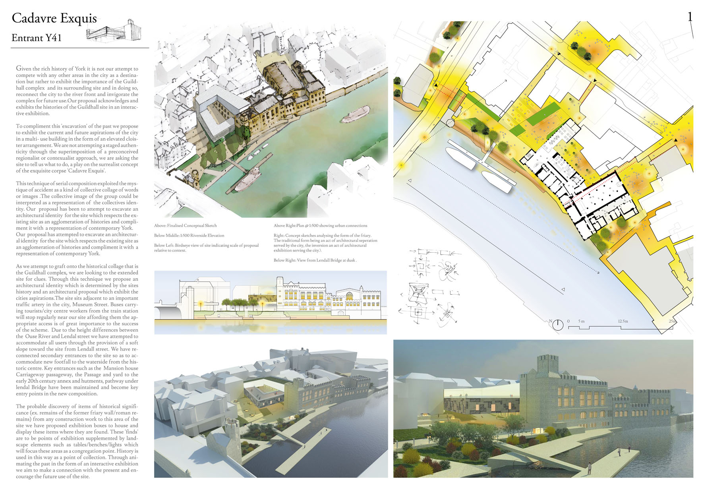

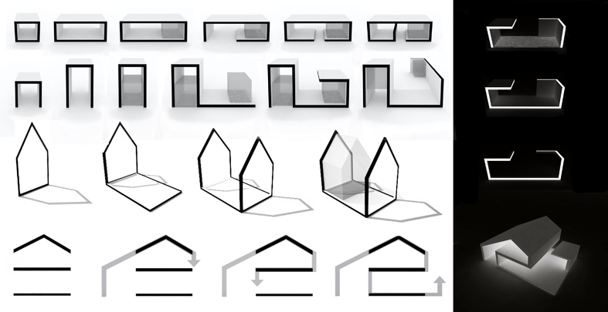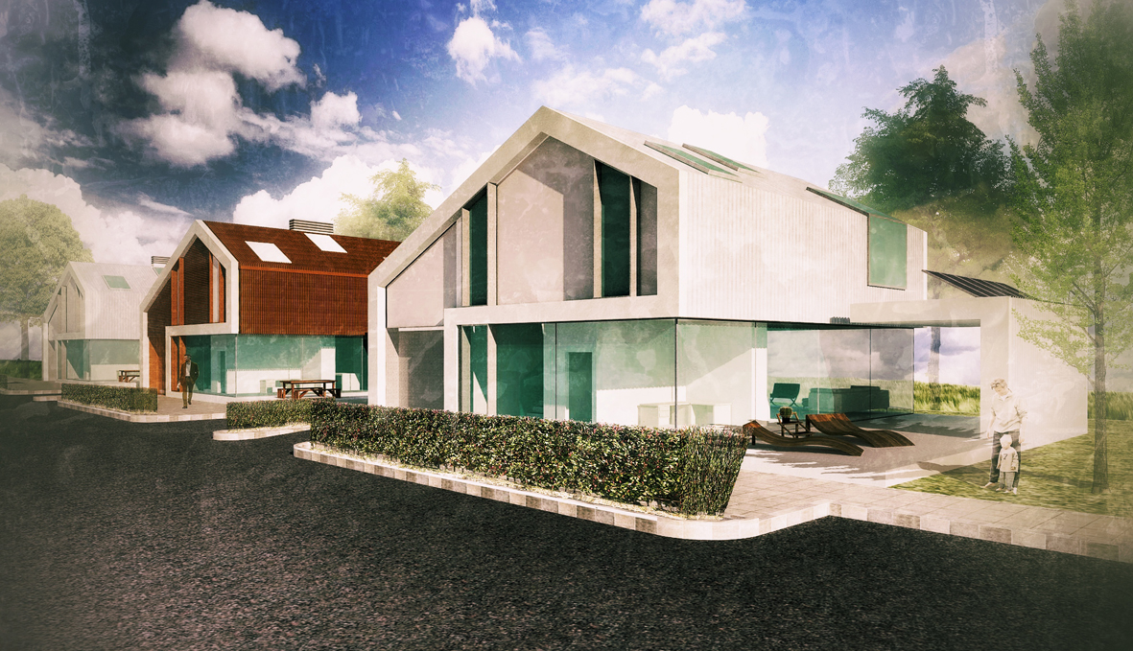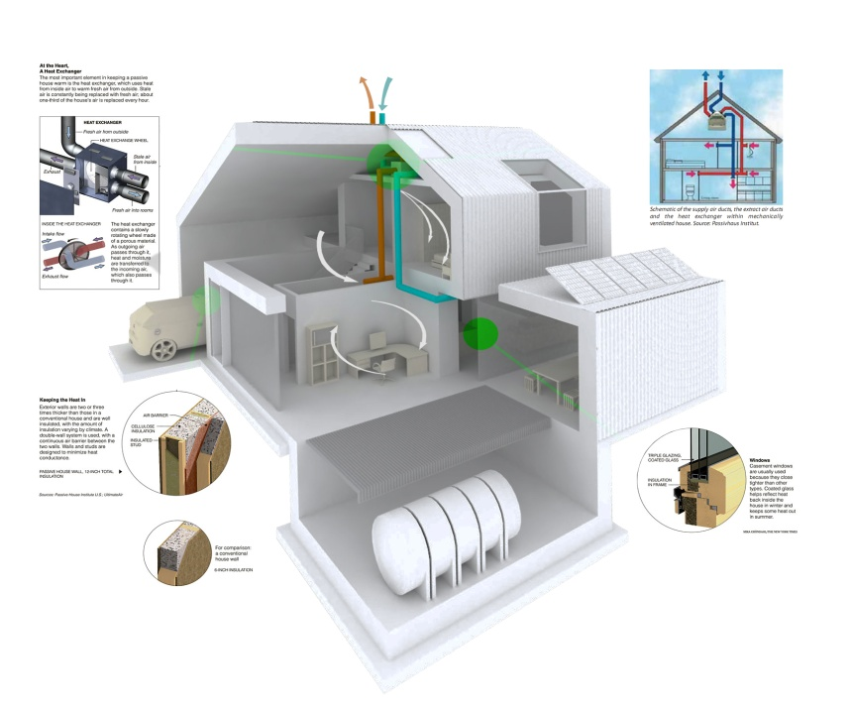**14 Passive House** In collaboration with Hugh Geoghegan 2013 Prototipe for a new passive house model for Ireland.



